Lab analog electronics: 1

Bram Vanderwegen

# 1 Introduction

A class c amplifier is an amplifier which amplifies a signal with a constant frequency and has applications in various fields. The layout of a class C amplifier is rather simple: a network of a capacitor, a inductor, and a resistor in parallel with a transistor in series. This is then put between a voltage and an input signal is applied to the base of the transistor. The values of the C, L and R components needs to be calculated in order to achieve the desired resonant frequency. Furthermore there are a few other parameters that need to be taken into account such as the quality factor and the maximum power consumption and are calculated using the following formulas.

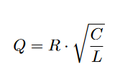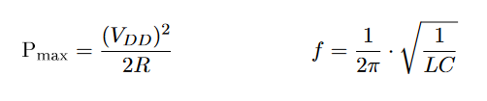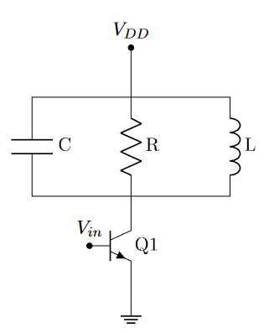

Figure : formulas for class C amplifier

Figure : Class C amplifier

# 2 methodology

This amplifier was build around the following parameters:

* VDD = 12V
* f = 70kHz
* Pmax = 0.15W
* Q = 10

Furthermore we used a ti-nspire calculator for the calculations and used LTspice for the simulations. The above mentioned formulas were used. The following schematic was used for the simulations:

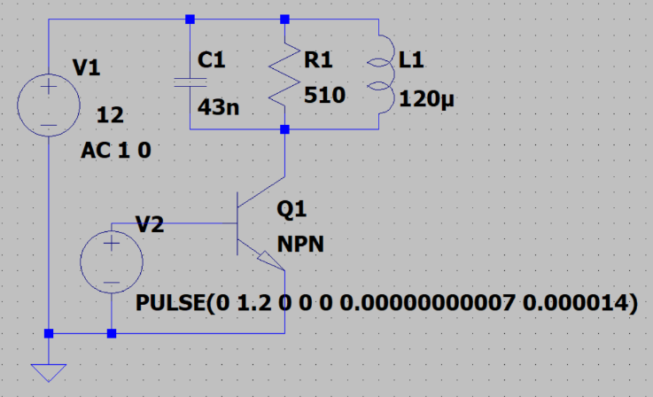

Figure : Schematic used for simulations

# 3 Simulation detail and results

## 3.1 Design of the components & quality factor Q

The Q factor is a factor which is a trade-off between energy efficiency and bandwidth, therefore a high Q factor would be more efficient but it would mean the operational bandwidth is lower and the component cost would increase to exactly match the desired frequency. We assumed the given value of 10 is satisfactory.

Using this information the following values were calculated:

Pmax = VDD2 / 2 R = 0.15> 🡺 R = 480 ohm

Here the resistance value is chosen higher as to not go over the maximum value while taking into account the accuracy of 5% for a realistic component which will be further discussed in the next section.

This was the calculation done using the calculator, this formula is a combination of two to extract the L and C value for a frequency of 70kHz and a quality factor of 10.

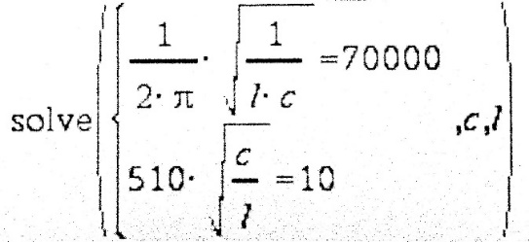

Figure : calculator input to calculate C and L at given frequency and quality factor

The results are: C = 44.58nF and L = 116µF

These values however are not realistic and should be replaced. Therefore the following standard values were chosen: C = 43nF and L = 120µF. To preserve the frequency, one value was chosen to be higher (L) and one value was chosen to be lower (C). The resulting resonant frequency: 70064Hz and Q: 9.65.

Resulting schematic:

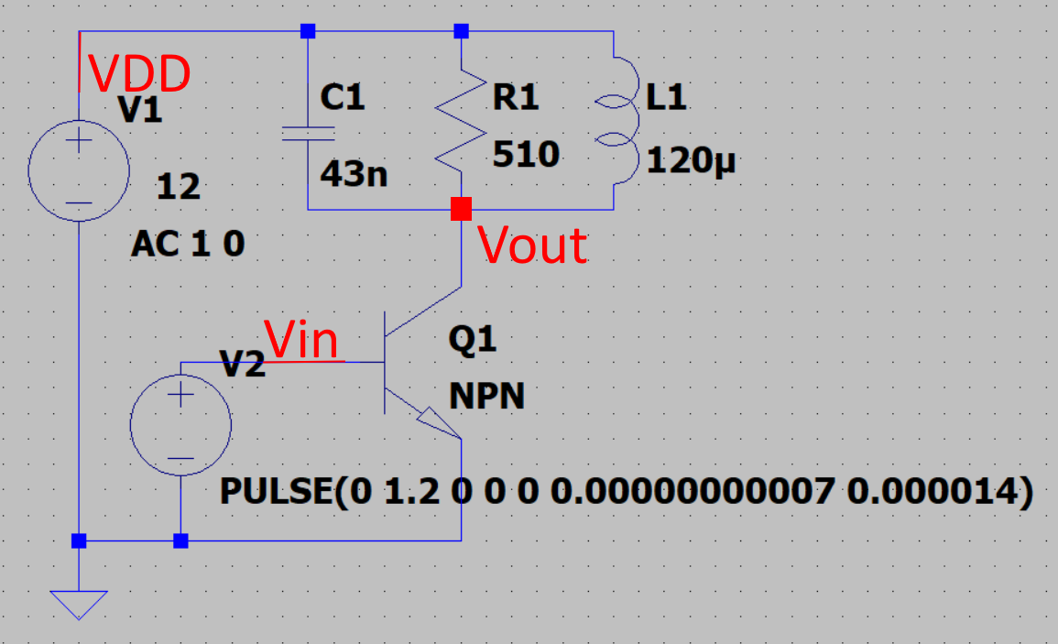

Figure : simulation schematic with important voltages

## 3.2 Operation of the amplifier in nominal conditions

### 3.2.1 Transient response

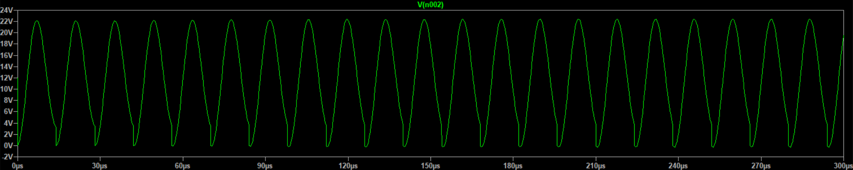

Figure : transient response

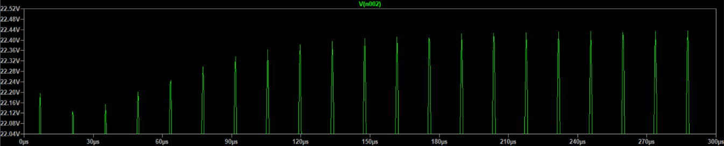

Figure : startup behaviour

The general transient response shows a constant oscillation and a pure sine wave. The only deviation is at the bottom of each cycle, where the transistor injects power. Here the voltage is pulled to 0V instead of floating a bit above the 0V line. The total amplitude is around 10V (22V-12V:max – halfway)

To examine the startup behaviour, a close up of the peaks was taken. When starting off the oscillation is a bit unstable but smooths out over time. The minimum it achieves in the beginning is 22.12V and within 300µs it stabilises to 22.40V.

### 3.2.2 Steady state simulation

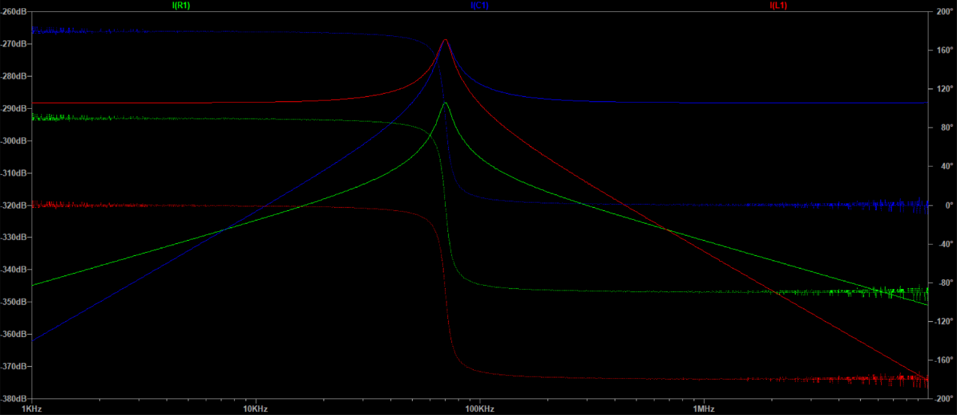

Figure : bode plot of the system frequency response

The frequency response was gathered for the currents through the passive components, the green plot, signifying the current through the resistor is especially important as it is directly related to the voltage over the component. The circuit clearly shows a high amplification at the 70kHz mark, as expected of a class c amplifier. This amplification diminishes in both directions of the frequency spectrum. The values of the amplification on the y-axis do not seem to match up, this is most likely due to simulation settings. Furthermore there is a clear 180° phase change whenever the signal crosses the 70kHz mark, that the importance between capacitor and inductor gets switched.

## 3.3 Operation of the amplifier outside the nominal conditions

### 3.3.1 Transient simulation

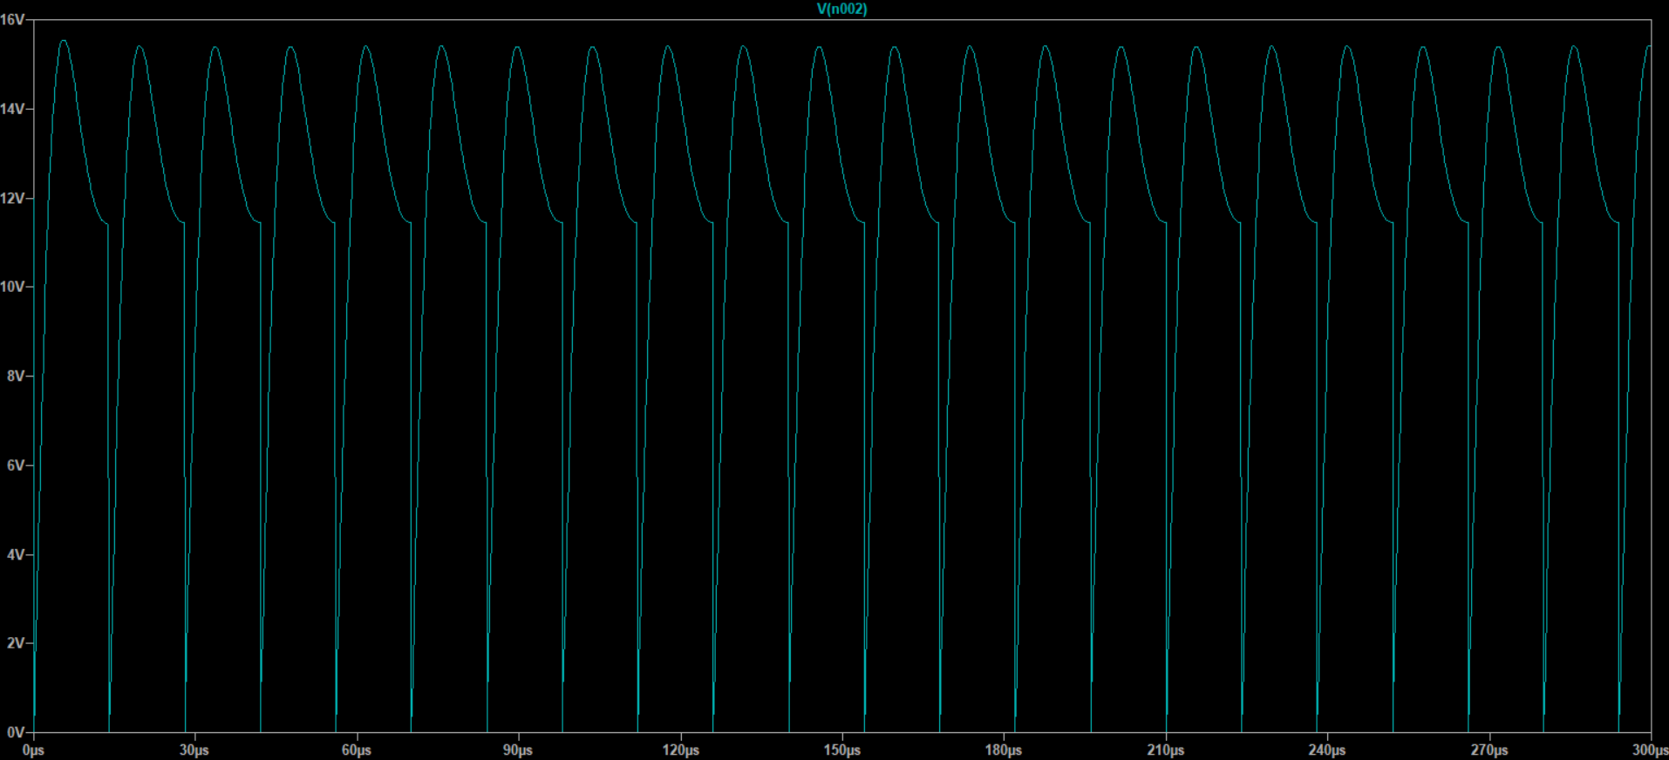

Figure : transient response at a quality factor of 1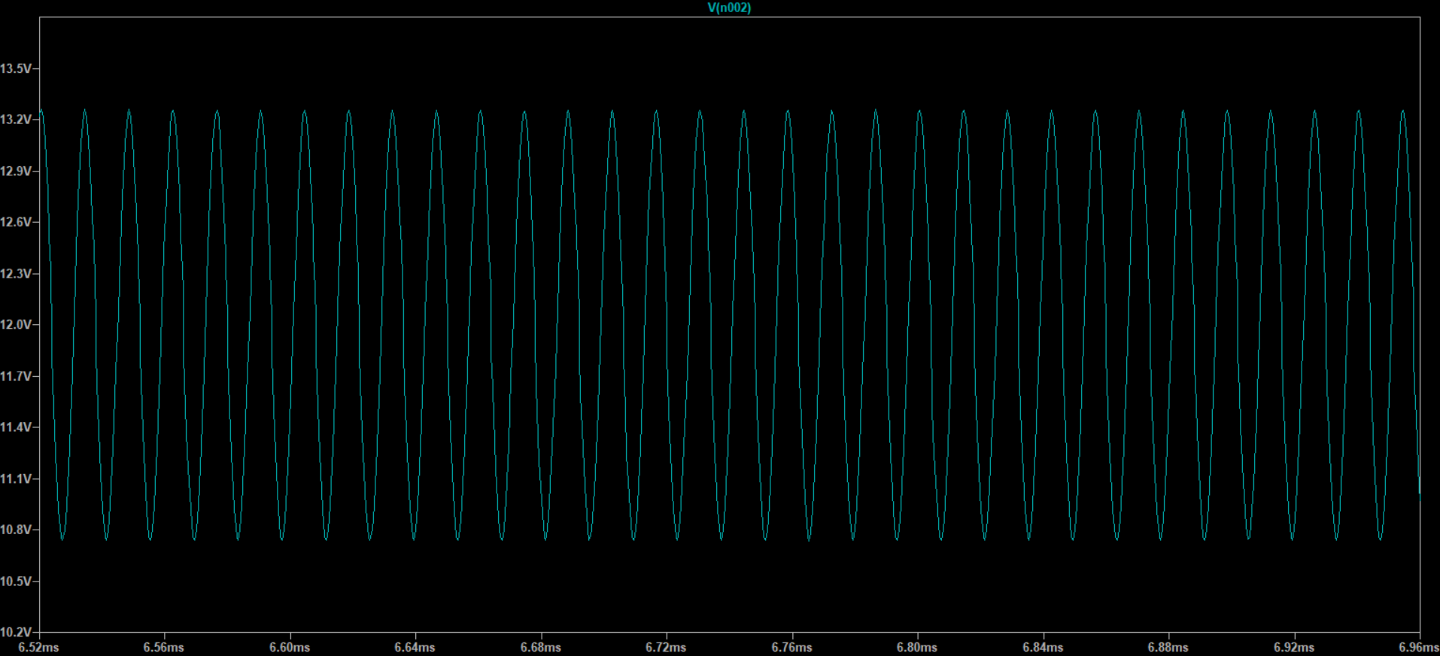

Figure : steady state response at a quality factor of 1000

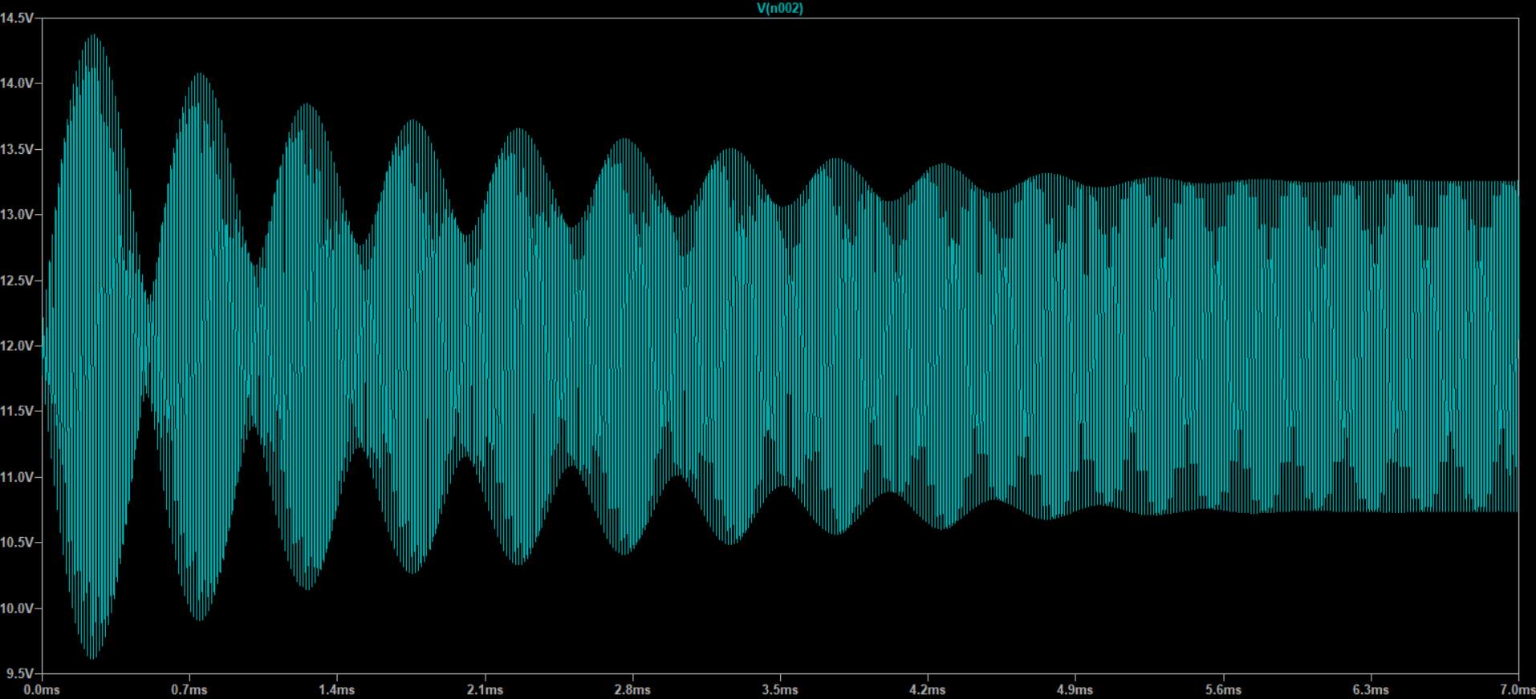

Figure : startup behaviour at a quality factor of 1000

Firstly the steady state transient characteristics. The waveform at Q=1 is clearly distorted as the transistor sinking power causes the graph to immediately sink to 0V. Furthermore the waveform, partly through distortion, doesn’t look at all like a pure sinewave. For example the leading edge is shorter in time than the falling edge. Finally, when observing the waveform, the wave seems to oscillate between 11.5V and 15.5V for a total amplitude of about 2V.   
The waveform at Q=1000 can be seen as a pure sinewave, not even experiencing distortion from the transistor. The amplitude is around 2V.  
When talking about the startup behaviour, the waveform at Q=1 does not seem to exhibit any deviations at startup and immediately starts oscillating at the constant characteristic. The one at Q=1000 however does exhibit a lot of start up behaviour as it oscillates a lot before settling at a constant at 7ms.  
The amplitudes of both plots are substantially lower than the original one at q=10.

### 3.3.2 steady-state simulation

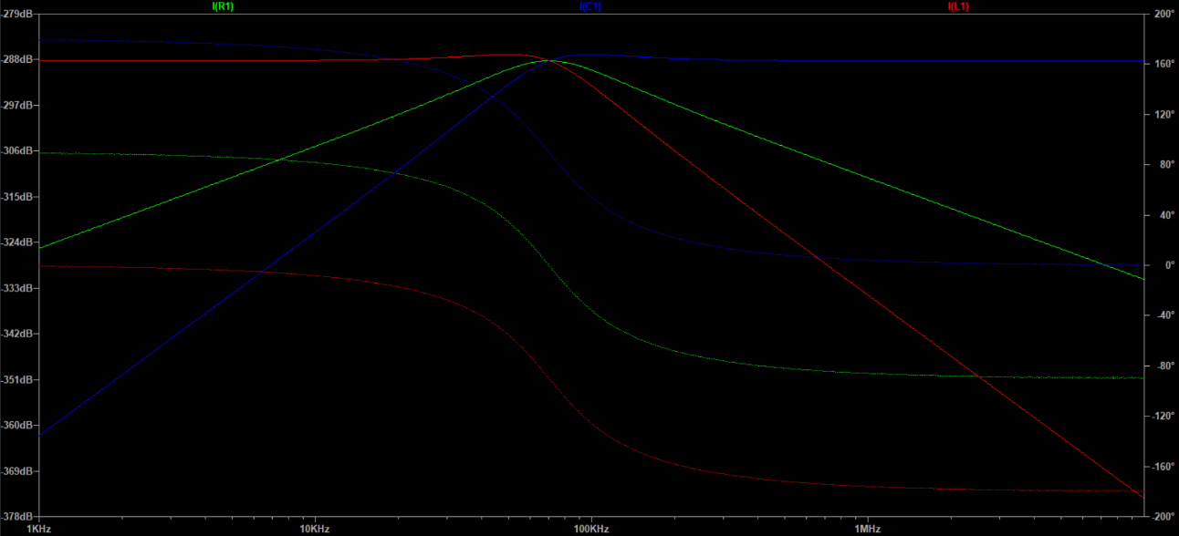

Figure : frequency bode plot at Q=1

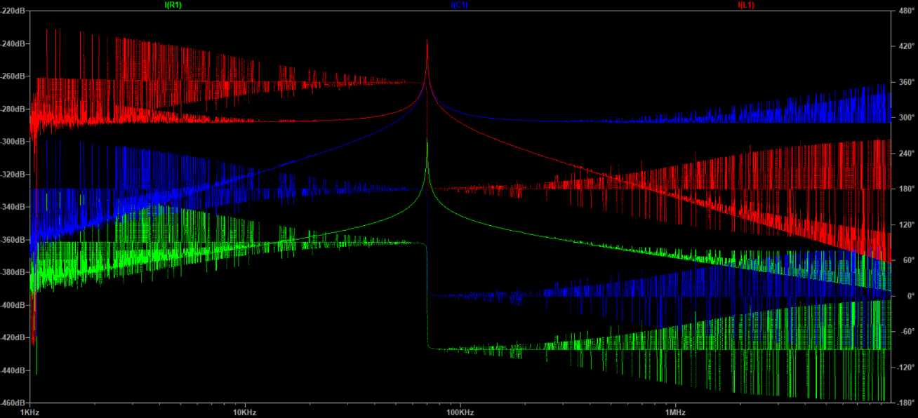

Figure : frequency bode plot at Q=1000

The bode plot at Q=1 shows the amplification plot is way flatter at the top, indicating a higher bandwidth. Here it is also visible that the amplification for the capacitor and inductor reach maxima at different frequencies. The bode plot for Q=1000 shows a pointier maximum, indicating a way lower bandwidth. The noise visible on the plots is most likely due to simulation error.

# 4 conclusion

The class c amplifier simulation worked as intended. Choosing the parameters for the parts was pretty straightforward. The resistor is just based on the maximum power consumption. The capacitor and inductor values however are a bit more interesting. They need to be calculated by combined the formulas for frequency and quality factor. While frequency is straightforward, quality factor is not. Throughout this lab the main point of interest was the quality factor. Increasing or reducing it changed the way the amplifier reacted substantially. While generally a high Q factor should be as high as possible for maximum efficiency, the transient plot at Q=1000 showed the bandwidth is also important. As the amplitude was lower which is probably due to a mismatch in frequency. This further illustrates the importance as real components do not have the exact values calculated by the formulas. Also, these components have tolerances, meaning the exact ratings change from component to component. When for example mass producing a class c amplifier (sub)circuit. A high Q factor with its small bandwidth could make the operation of the devices different from sample to sample because of the tolerances. This argument implies the Q factor should be lower. Therefore the optimal Q factor is a difficult value to consider. In the end this would be a trade-off between efficiency and cost (components with lower rating deviations are more expensive). Another thing that should be noted is that a high Q factor makes the startup behaviour last longer. This however is usually of little importance as it can easily be dealt with by using for example a time delay for outputting the oscillation.